***GitHub and Remote Repositories***

**Remote Repository:**  A repository that’s hosted on somebody else’s server or somebody else’s computer using github.

Add git repositories using commands.

Origin is the name of remote. And it’s conventional name.

**Syntax:**

**Git remote add origin <link of repository which we created on github>**



Now this remote is created and we can push repository to that remote.

**Push local repository to remote repository:**

Using u flag of u option which links up remote and local repository. 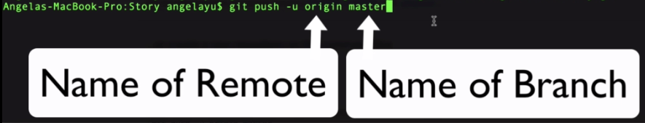

The master branch is the basically default branch of the main branch of all of your commits.

**git remote add origin https://github.com/MuhammadAhmad123a/Story.git**



**…or create a new repository on the command line**

echo "# Story" >> README.md

git init

git add README.md

git commit -m "first commit"

git branch -M main

git remote add origin https://github.com/MuhammadAhmad123a/Story.git

git push -u origin main

**…or push an existing repository from the command line**

git remote add origin https://github.com/MuhammadAhmad123a/Story.git

git branch -M main

git push -u origin main

<https://www.freecodecamp.org/news/error-src-refspec-master-does-not-match-any-how-to-fix-in-git/>

